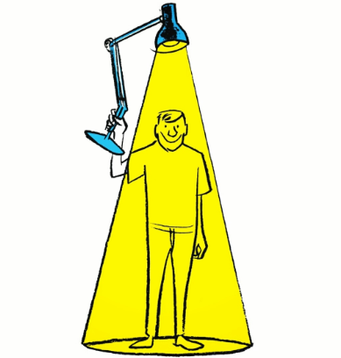
A bright,beautiful,warm day.I'm lying on the bed,spoiled by the vaccations, wanting to sleep more, but the excitement of meeting my friends after a whole month won't let me sleep.

Yet,even with my eyes open,I fall into an amalgamated world of imagination and reminiscence.

Running wild through the maze like corridors,skipping classes to have a few more minutes of football,giving comical answers to teacher's questions,making everyone laugh at it,and then giving the right answer as a surprise element,being good in everyone's book is all I ever want.

We have new guys this year in the group,one of them was a little shy but now that he has opened up,he is top ranked in the craziest people we know.

"Mom,just 5 more minutes! Please?" and a voice wakes me up,here I am,sitting in front of a computer screen,analysing stocks and making calls.This girl- Alisha, was the one calling my name, to save me from our supervisor taking rounds.

See,I wouldn't be wrong to say,the chemistry between Alisha and me is beyond just friendship. She has been my rescuer in multiple hardships, from failing to pay my rents due to excessive partying, to helping me ace deadlines during sickness.

Never have I ever met a heart so pure, and my friends from office have been suggesting me to propose to her this birthday, for her friends tell she has a soft corner for me too.These crazy guys got a whole theatre booked to get the cause in motion,maybe,paying me back for all the booze.

Here we are,in this theatre,and since I snuck in a bottle,having drinks. I'm nervous. She seems nervous too. We're both dizzy, strong stuff I guess.The darkness is increasing, I close my eyes.

"Mom,5 more minutes,please?" as a voice wakes me up. It's winter. First day to school,since the vaccation.

The warden is fired up at me, for I'm late.

Today's Alisha's birthday, and I have nothing to gift her. Doesn't matter, she doesn't even know my name.

Well, I could put up this band aid on my face,
And maybe, someone would ask If I'm okay.
I miss my mom.

